**Assignment Week 3 Collections**

**Program 1: Create a custom hash map.**

import java.util.ArrayList;

import java.util.List;

public class _01_CustomHashMapTest {

    public static void main(String[] args) {

        HashMapCustom<String, Integer> hm = new HashMapCustom<>();

        hm.put("A1", 1);

        hm.put("A2",2);

        hm.put("A3",3);

        hm.put("A4",4);

        System.out.println(hm);

        System.out.println(hm.get("A1"));

        System.out.println(hm.get("Kuldeep"));

        hm.remove("A1");

        System.out.println(hm);

        System.out.println(hm.get("A1"));

    }

}

 class HashMapCustom<K, V> {

    // Class representing the <Key,Value> pair node

    private class MapNode<K, V> {

        private K key; // to store the key

        private V value; // to store the value

        private MapNode<K, V> next; // to store the reference of the next element

        MapNode(K key, V value) {

            this.key = key;

            this.value = value;

        }

        @Override

        public String toString() {

            return "MapNode [key=" + key + ", value=" + value + ", next=" + next + "]";

        }

    }

    // K is the key type

    // V is the value type

    private List<MapNode<K, V>> bucket;

    private int capacity; // length of the bucket

    private int size; // number of elements in the map

    private final int INITIAL_CAPACITY = 5; // initial length of the bucket array

    private final double THRESHOLD_LOAD_FACTOR = 0.75d; // the threashold load factor

    public HashMapCustom() {

        bucket = new ArrayList<>();

        capacity = INITIAL_CAPACITY;

        // we add the "capacity" number of elements to the list

        // because if we don't the list would have a size 0

        // we need to ensure that the required indices exist

        for (int i = 0; i < capacity; i++) {

            bucket.add(null);

        }

        /*

         * Note- We are using List here and not array.

         * Since, we are dealing with generic types, we cannot use

         * array. Also, since the size is dynamic, we cannot use

         * array.

         */

    }

    // this method will give the bucket index by

    // finding the hashcode and applying the compression function

    private int getBucketIndex(K key) {

        int hashcode = key.hashCode(); // Object hashcode() method returns the hashcode

        System.out.println("Hashcode for " + key + " is: " + hashcode + " index: " + (hashcode % capacity));

        return Math.abs(hashcode % capacity); //return absolute to prevent negative values

    }

    public V get(K key) {

        // get the index

        int bucketIndex = getBucketIndex(key);

        // Get the head of the list at the bucketIndex

        MapNode<K, V> head = bucket.get(bucketIndex);

        while (head != null) {

            // use equals() method and not the == operator

            // since the key can be an object and == will

            // just compare the memory address

            // This also shows that we must always implement the

            // equals and hashcode methods for whichever key we want

            // to use

            if (head.key.equals(key)) {

                return head.value;

            }

            head = head.next;

        }

        // if the key does not exist

        return null;

    }

    public void put(K key, V value) {

        // get the index

        int bucketIndex = getBucketIndex(key);

        // get the head of the list

        MapNode<K, V> head = bucket.get(bucketIndex);

        // check if the corresponding entry is present or not

        while (head != null) {

            if (head.key.equals(key)) {

                head.value = value;

                return;

            }

            head = head.next;

        }

        // if the key is not present, then insert it

        size++;

        MapNode<K, V> newEntry = new MapNode<>(key, value);

        head = bucket.get(bucketIndex);

        newEntry.next = head;// add the new node at the first position

        bucket.set(bucketIndex, newEntry);

        // Once added now we need to take care of the load factor.

        // Calculate the current load factor

        double loadFactor = (1.0 * size) / capacity; // number of elements/number of buckets

        System.out.println("Load factor: " + loadFactor);

        if (loadFactor > THRESHOLD_LOAD_FACTOR) {

            rehash();

        }

    }

    private void rehash(){

        System.out.println("Rehashing...");

        List<MapNode<K,V>> temp=bucket;

        bucket=new ArrayList<>(); //re-initialize

        capacity*=2; //double the capacity

        for(int i=0;i<capacity;i++){

            bucket.add(null);

        }

        size=0; //for the new bucket

        //rehash each entry

        for(int i=0;i<temp.size();i++){

            MapNode<K,V> head=temp.get(i);

            while(head!=null){

                put(head.key,head.value);

                head=head.next;

            }

        }

    }

    public void remove(K key) {

        // get the index

        int bucketIndex = getBucketIndex(key);

        MapNode<K, V> head = bucket.get(bucketIndex);

        MapNode<K, V> prev = null;

        while (head != null) {

            if (head.key.equals(key)) {

                if (prev == null) {

                    bucket.set(bucketIndex, head.next);

                } else {

                    prev.next = head.next;

                }

                head.next = null;

                size--;

                break;

            }

            prev = head;

            head = head.next;

        }

    }

    @Override

    public String toString() {

        return "HashMapCustom [bucket=" + bucket + ", capacity=" + capacity + ", size=" + size + ", INITIAL_CAPACITY="

                + INITIAL_CAPACITY + "]";

    }

}

**Output-**

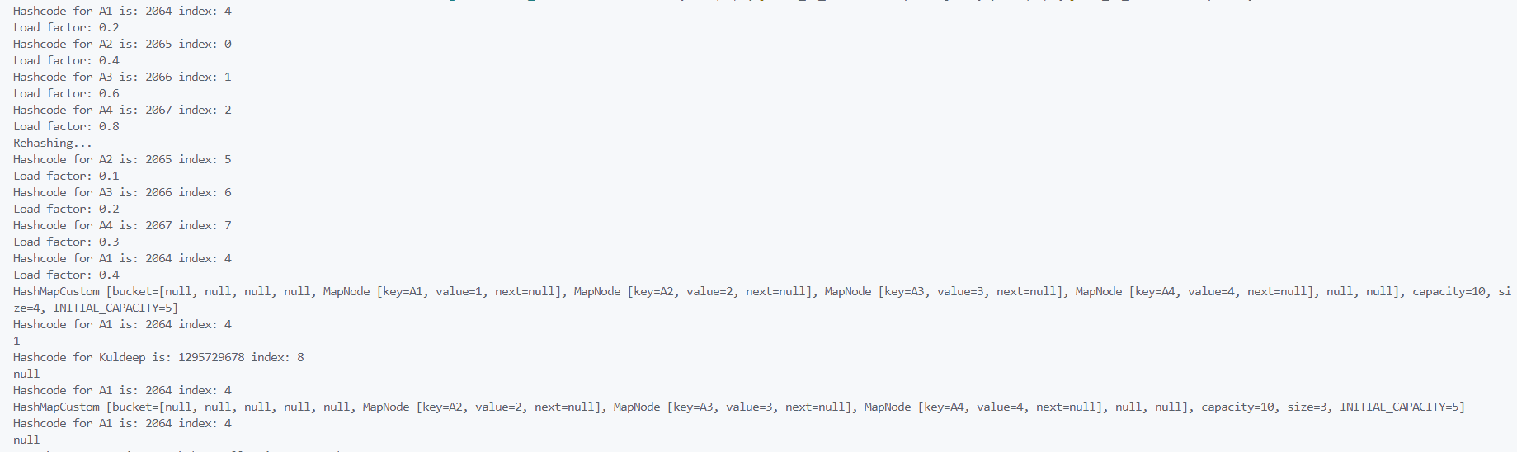

**Program 2: Implement Stack using Arrays or List**

public class _02_StackImpl {

    public static void main(String[] args) {

        Stack_Array stk1 = new Stack_Array(5);

        testArrayStack(stk1);

    }

    private static void testArrayStack(Stack_Array stk1) {

        stk1.push(209);

        stk1.push(345);

        stk1.push(45);

        System.out.println("Top element of the array stack: " + stk1.peek());

        System.out.println("Is empty: " + stk1.isEmpty());

        System.out.println("Is full: " + stk1.isFull());

        stk1.push(24);

        stk1.push(25);

        stk1.push(25);

        System.out.println("Is full: " + stk1.isFull());

        stk1.pop();

        stk1.pop();

        stk1.pop();

        stk1.pop();

        stk1.pop();

        stk1.pop();

    }

}

class Stack_Array {

    private int maxSize;

    private int[] stackArray;

    private int top;

    public Stack_Array(int size) {

        this.maxSize = size;

        this.stackArray = new int[maxSize];

        this.top = -1;

    }

    public void push(int value) {

        if (isFull()) {

            System.out.println("Stack overflow! " + value);

            return;

        }

        stackArray[++top] = value;

        System.out.println("Pushed " + value);

    }

    // Method to pop an element from the stack

    public int pop() {

        if (isEmpty()) {

            System.out.println("Stack underflow!");

            return -1;

        }

        int poppedElement = stackArray[top--];

        System.out.println("Popped " + poppedElement);

        return poppedElement;

    }

    public int peek() {

        if (isEmpty()) {

            System.out.println("Stack is empty!");

            return -1;

        }

        return stackArray[top];

    }

    public boolean isEmpty() {

        return top == -1;

    }

    public boolean isFull() {

        return top == maxSize - 1;

    }

}

**Output:**

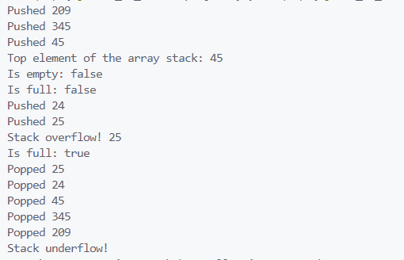

**Program 3: Sort array of 0s and 1s efficiently**

import java.util.Arrays;

public class _03_Sort_Arrays_of_0and1 {

    public static void main(String[] args) {

        int arr[] = { 1, 0, 1, 0, 0, 1, 1, 0, 0, 0 };

        System.out.println("Array before sorting: " + Arrays.toString(arr));

        int n = arr.length;

        sortArray(arr, 0, n - 1);

        System.out.println("Array after sorting: " + Arrays.toString(arr));

    }

    private static void sortArray(int[] arr, int i, int j) {

        while (i < j) {

            if (arr[i] == 1) {

                int temp = arr[i];

                arr[i] = arr[j];

                arr[j] = temp;

                j--;

            } else {

                i++;

            }

        }

    }

}

**Output:**



**Program 4: Check for balanced parentheses**

import java.util.Stack;

public class _4_BalancedParentheses {

    public static void main(String[] args) {

        String s="[{()}]";

        String s2="[{()}";

        String s3="[{}{}([]";

        System.out.println("Is "+s+" valid: "+isValid(s));

        System.out.println("Is "+s2+" valid: "+isValid(s2));

        System.out.println("Is "+s3+" valid: "+isValid(s3));

    }

    public static boolean isValid(String s) {

        Stack<Character> stack = new Stack<Character>();

        for (char c : s.toCharArray()) {

            if (c == '(' || c == '[' || c == '{') {

                stack.push(c);

            } else {

                if (stack.isEmpty()) {

                    return false;

                }

                char top = stack.peek();

                if ((c == ')' && top == '(') || (c == ']' && top == '[') || (c == '}' && top == '{')) {

                    stack.pop();

                } else {

                    return false;

                }

            }

        }

        return stack.isEmpty();

    }

}

**Output:**

